Circuit 1: 2s 4-Bit Adder-Subtractor and Adder

1- Photos of Circuit :
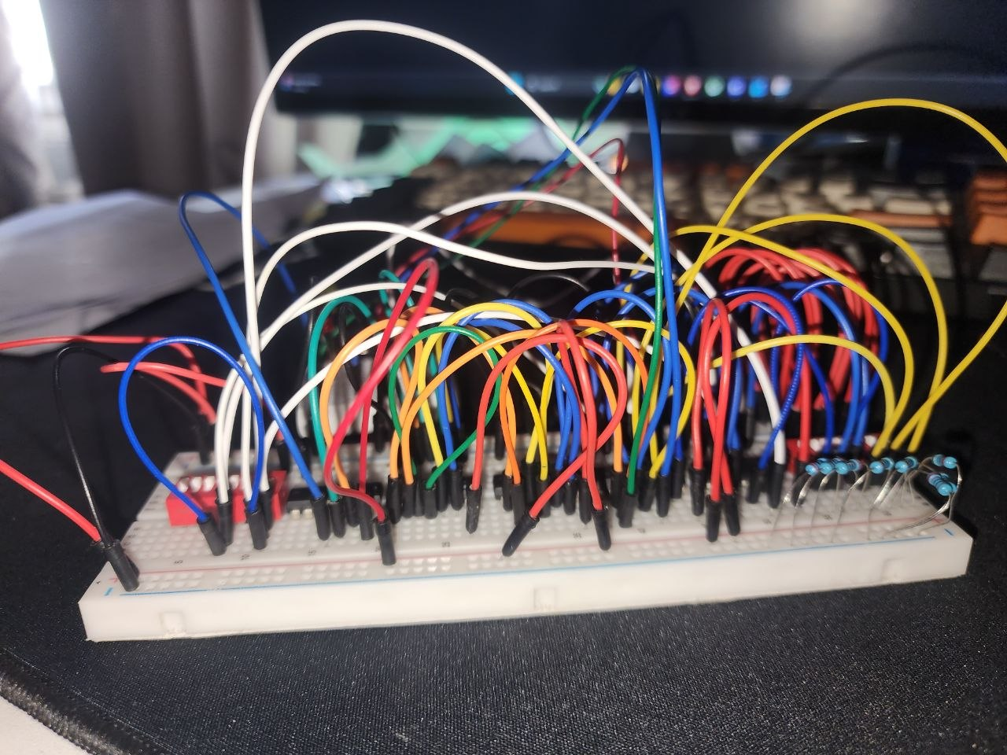
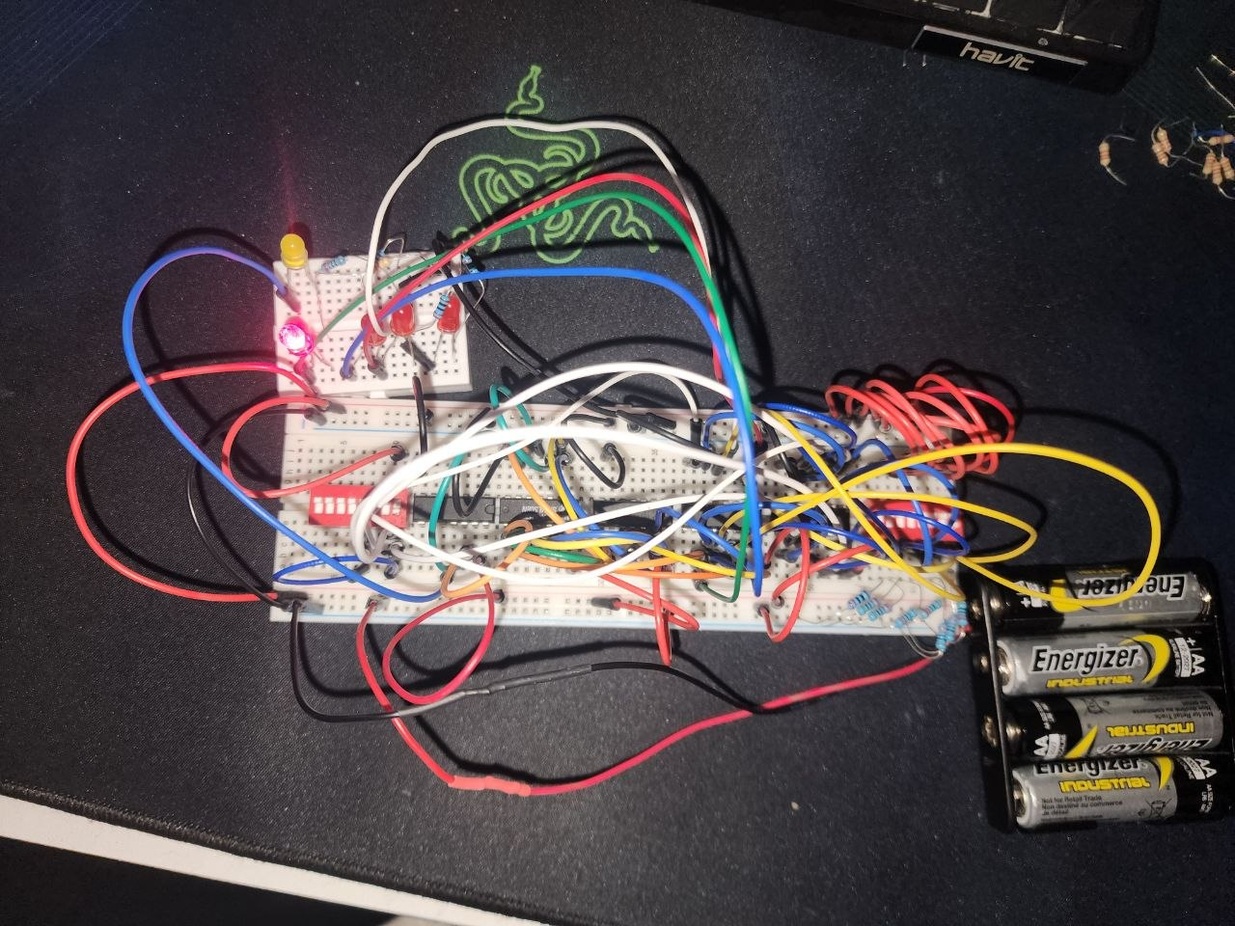

KiCad Screenshot:
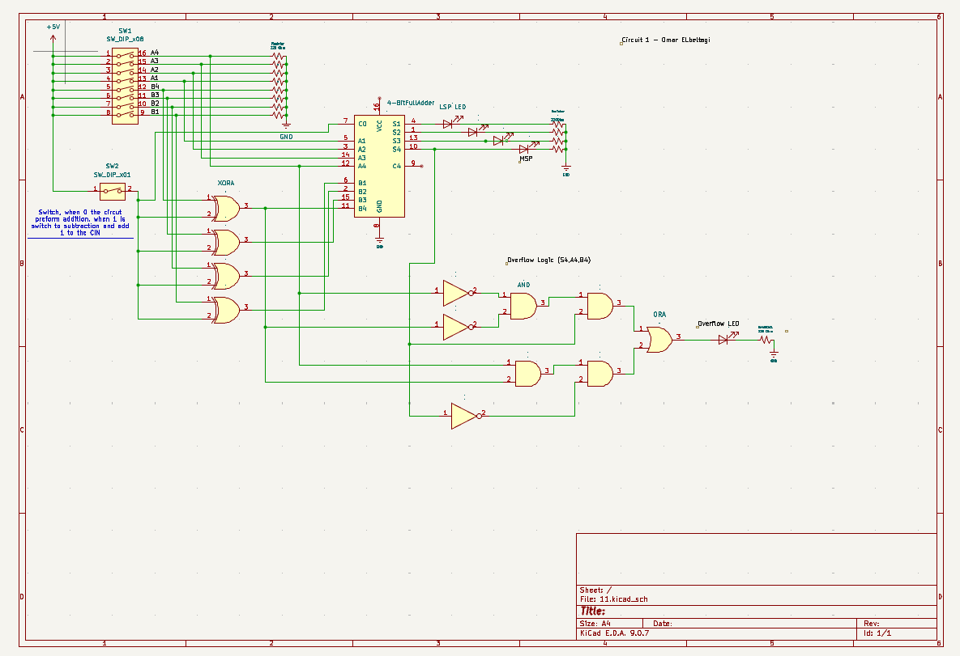

XOR Truth Table:
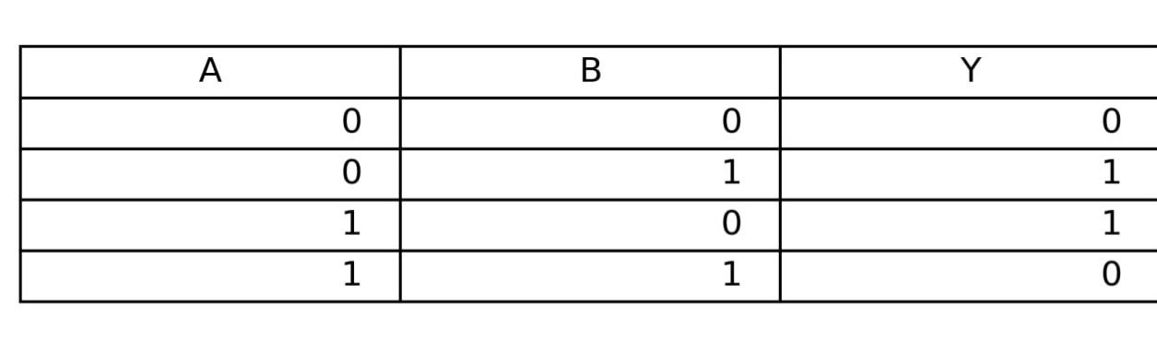

OverFlow Logic truth table:
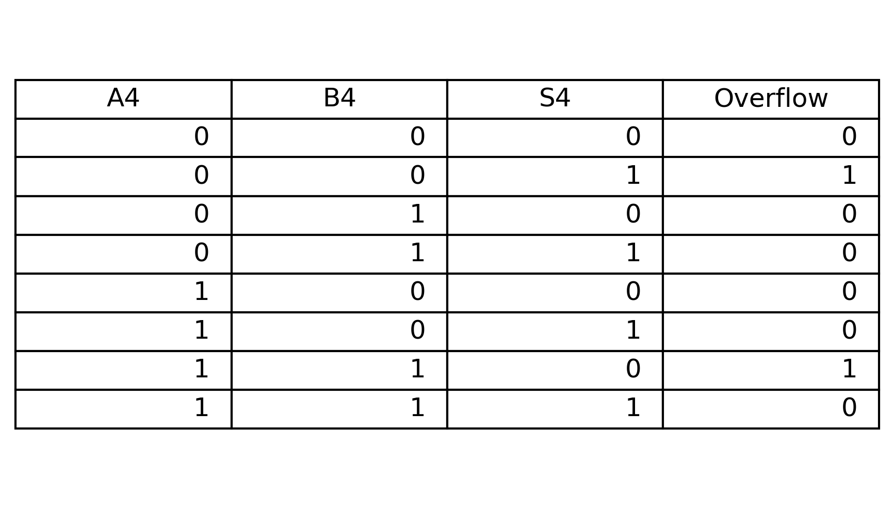
Tinkercad :
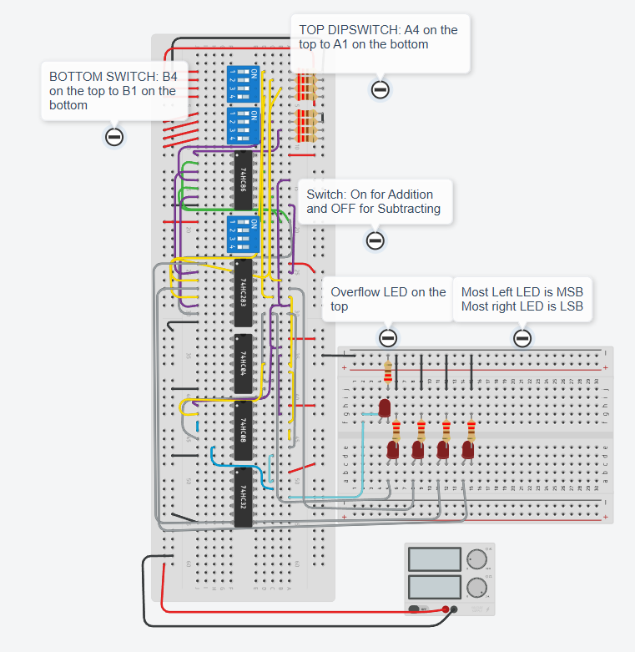
The Link for the Circuit

Description:

The circuit shown is a 4-bit 2’s complement adder-subtractor with an overflow LED.
Starting with the addition operation, the circuit performs addition using a 74LS283 full adder chip. Each input bit (A4–A1 and B4–B1) is directly connected from the DIP switches to the corresponding inputs on the adder. This allows the circuit to produce the binary sum of the two numbers.
For subtraction, the circuit works by adding the two’s complement of B (A + (−B)). This is done by using XOR gates. The XOR gates act as controlled inverters; when the control switch is off, B passes through unchanged, but when the switch is on, each bit of B is inverted, this matches the XOR truth table and allows the circuit to switch between addition and subtraction.
Changing the variables A and B to a control switch and input B respectively, we can see the behavior of the XOR gates. When the switch is OFF, B passes through unchanged, meaning the output is the same as B. When the switch is ON, the XOR gate acts as an inverter, flipping the value of B (0 becomes 1, and 1 becomes 0).
In addition, the switch is connected to the carry-in of the adder, when the switch is ON, it adds a value of 1, completing the two’s complement operation. This effectively converts B into its negative form (−B), allowing the circuit to perform subtraction using addition.
The overflow logic is derived from the truth table using A4, B4, and S4, as shown in the OverFLOW Logic truth table. In 2’s complement arithmetic, overflow occurs when adding two numbers with the same sign produces a result with a different sign. For example, when A4 = 0 and B4 = 0 but S4 = 1, this indicates overflow because two positive numbers resulted in a negative output. Similarly, when A4 = 1 and B4 = 1 but S4 = 0, overflow also occurs. From this, we derive the overflow equation:
F = A4·B4·S4' + A4'·B4'·S4
This logic can be implemented using NOT, AND, and OR gates. Since subtraction is performed by adding the two’s complement of B, the overflow detection works for both addition and subtraction operations.

